Assignment – 4

SMS SPAM Classification

|  |  |
| --- | --- |
| Assignment Date | 10 NOVEMBER 2022 |
| Student Name | AMIRTHA.P |
| Student Roll Number | 721819205004 |
| Maximum Marks | 2 Marks |

**TASKS:**

1. Download the dataset
2. Import required library

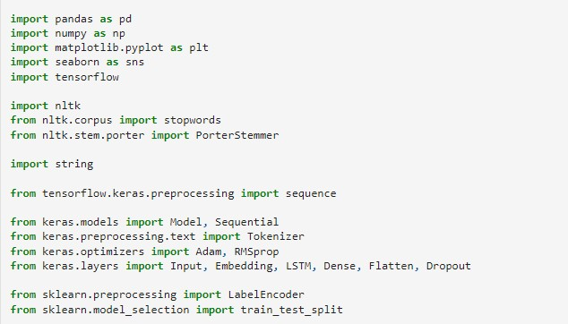

1. Read dataset and do Pre-processing

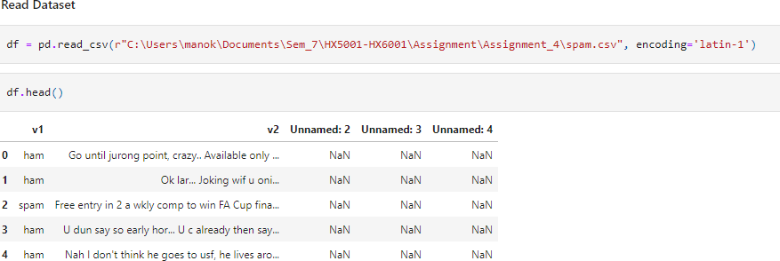

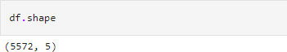

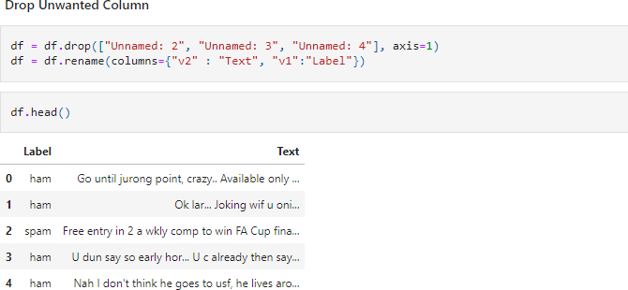

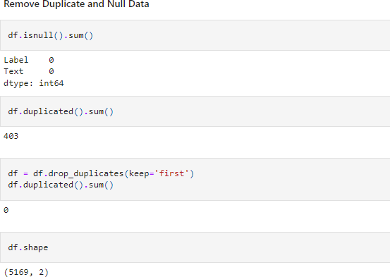

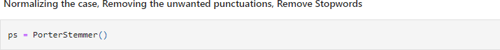

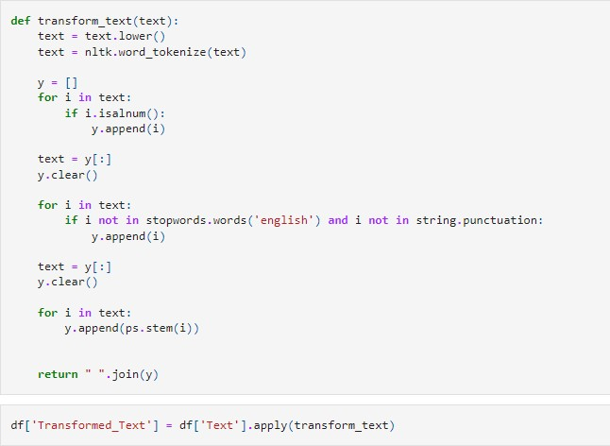

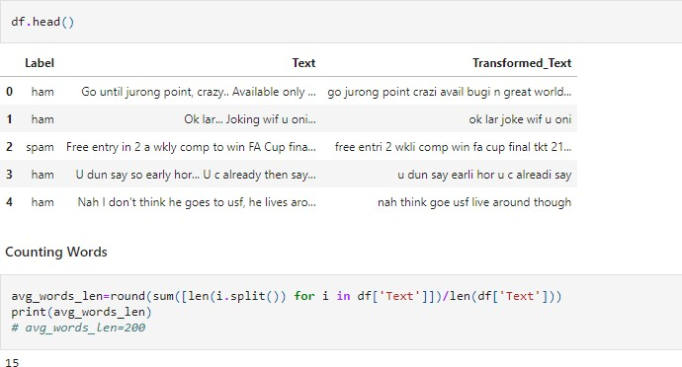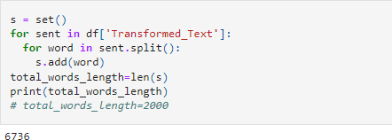

1. Create model

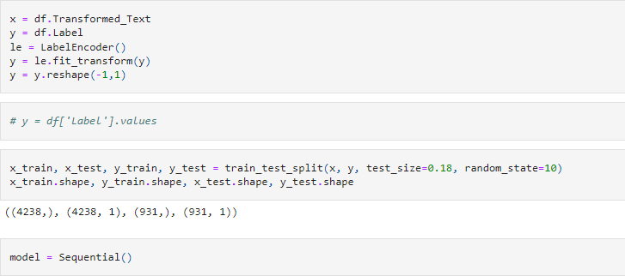

1. Add layers

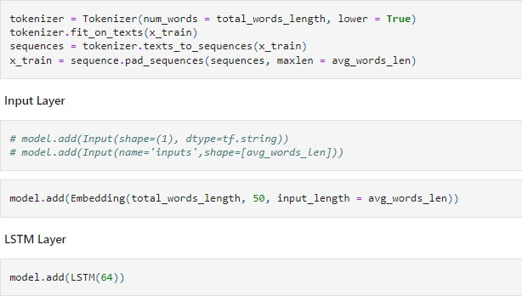

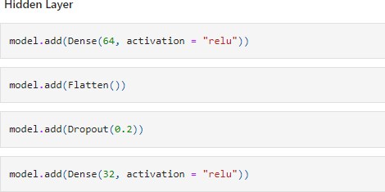

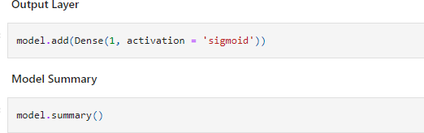

Model: "sequential"

Layer (type) Output Shape Param #

=================================================================

|  |  |  |  |  |
| --- | --- | --- | --- | --- |
| embedding (Embedding) | (None, | 15, | 50) | 336800 |
| lstm (LSTM) | (None, | 64) |  | 29440 |
| dense (Dense) | (None, | 64) |  | 4160 |
| flatten (Flatten) | (None, | 64) |  | 0 |
| dropout (Dropout) | (None, | 64) |  | 0 |
| dense_1 (Dense) | (None, | 32) |  | 2080 |
| dense_2 (Dense) | (None, | 1) |  | 33 |

=================================================================

Total params: 372,513

Trainable params: 372,513

Non-trainable params: 0

1. Compile the model



1. Fit the model



Epoch 1/5

424/424 [==============================] - 16s 14ms/step - loss: 0.1346 - a

ccuracy: 0.9552 Epoch 2/5

424/424 [==============================] - 6s 15ms/step - loss: 0.0356 - ac

curacy: 0.9887 Epoch 3/5

424/424 [==============================] - 6s 15ms/step - loss: 0.0203 - ac

curacy: 0.9941 Epoch 4/5

424/424 [==============================] - 6s 14ms/step - loss: 0.0096 - ac

curacy: 0.9969 Epoch 5/5

424/424 [==============================] - 6s 15ms/step - loss: 0.0043 - ac

curacy: 0.9988

1. Save the model
2. Test the model

